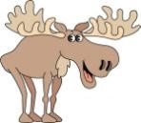 Newsletter Sept. 2020-Jan. 2021 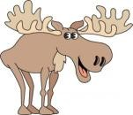
LEWISTON MOOSE FAMILY CENTER #2495
Phone: 989-786-4388 FAX: 989-786-2791
www.lewistonmoose2495.org
Facebook: Lewiston Moose 2495

2020 - 2021 OFFICERS:

GOVERNOR –HARRY PAGÁN 3 YEAR TRUSTEE – RICHSRD KOSS
ADMINISTRATOR – PAT SIESZPUTOWSKI 2 YEAR TRUSTEE – KEN HONEYCUTT JR. PAST GOVERNER – CHARLES WARREN 1 YEAR TRUSTEE – JIM HUBBARD
JR. GOVERNOR –N/A TREASURER – ALBERT MARSHALL
PRELATE –DAVE LLOYD SERGEANT-AT-ARMS – KEVIN O’KEEFE
HOME LODGE OF M.M.A. PRESIDENT RON HOADLEY

THE MOOSE FRATERNITY
"An International Organization of Men and Women Dedicated to Caring for
Young and Old, Bringing Communities Closer Together, and Celebrating Life."
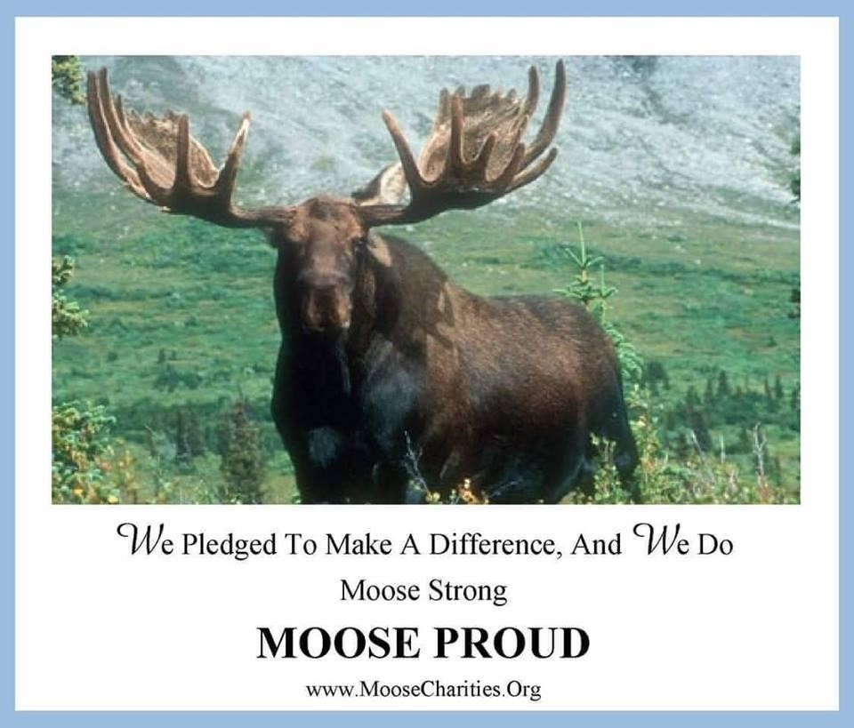
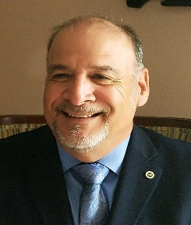

Governor, Harry Pagán
Hello everyone, remember me? Well I’m at it again. I will be the lodge governor for the remainder of this CRAXY YEAR. Before I continue, I would like to extend kudos to Chuckie Warren and his administration for doing a fine job. The work never stops. I am happy to accept this nomination even though I ran unopposed. We are coming out of unexpected situation with this COVID stuff, but we are taking some steps in keeping the lodge clean as best we can. We are also trying to conduct business as normal as possible so that we will not be too strapped in the coming winter months. The Moose organization will be going through some restructuring in the coming year as we start to merge the men and women into “One Moose” and I’m very excited to be at the helm during this momentous occasion. Who knows, our next Jr Governor could be one of our hard-working women next year. We’ll get more clarification as we approach 2021. Please continue to support our lodge, we could use all the help we can get, and speaking of HELP, MMMMMMMM, NEED I SAY MORE? The car show folks have been ROCKING IT! Let them know you notice. Aline, George, Chuckie, Jim and all his cooks, the girls selling the 50/50, Lana at the bar and her Jerry doing everything to keep her stocked. I would also like to give a shout out to Mark and Mary Becker Who Sponsor our Car Cruise and have introduced our lodge to countless people, some who have become members as well. If you need to sell or buy a house, see Mary. We cannot forget our Moose drop Girls; THEY REALLY ARE THE SHIT. Sizzling Patti on the flattop, Fryer Polly chunkin’ and dunkin’ and Ching Ching Nancy on the register I am very proud of all our volunteers. The garden is looking nice this year so long as the deer stay away. Great job to Debbie the “GARDNA” and Patti. They do a great job. Last but not least, the boys in the front office, yes it takes a good team of trustworthy men and women to make an organization, even as small as ours, to run smooth. Very few, and I mean very few members actually know how much work and effort it takes from them to smooth out our rough edges and they do it every day we are open. It’s all because of these guys that we look like we know what we are doing. Pat Sieszputowski, Albert Marshall, Jim Hubbard and Ken Honeycutt. So, now that I’ve SUCKED UP to all you wonderful people, remember that we are known by many as a VERY FRIENDLY LODGE, and that’s no lie. Greet everyone that comes through our doors.
Harry Pagán
Governor

Upcoming Conventions

2020 MICHIGAN MOOSE ASSOCIATION
September 11th, 2020 1pm-3:30pm and 5:30pm-8pm
Annual Convention will be virtual this year. ALL registration will take place online this year,
must register to be able to attend!
All meetings will be held on Zoom app, down load here.
Virtual Meeting Convention Agenda (Updated 8-20) LOOM Registration & WOTM Registration
Stay & Play Raffle Poster Green Cap Reg & Agenda Case or Cash Poster

One Moose Information
The Grand Council of the Women of the Moose and Supreme Council of the Loyal Order of Moose have worked hand-in-hand for the past two years to establish a strategic plan for women and men to have an equal voice, standing, and opportunity in every Moose Lodge throughout our Fraternity. The idea of “One Moose” membership has been around for decades and until now has only been about talking and not doing. The time has come for our Fraternity to take action and establish a path forward whereby a husband and wife, brother and sister, and female and male friends have the same opportunity to serve on the Board of Officers and have a lawful vote and voice into the business, programs and activities of the Lodge.
We recently held a Town Hall Meeting the first weekend of November. The weekend was full of open dialogue, presentations and panel sessions focusing on just one topic – One Moose Membership! Attendees heard from Grand Chancellor Barb McPherson, Director General Scott Hart, our Grand Regent Mary Froning, Supreme Governor Rodney Hammond, General Governor Mike Leuer and Director of Membership Mike Rios on the future of our Moose fraternity.

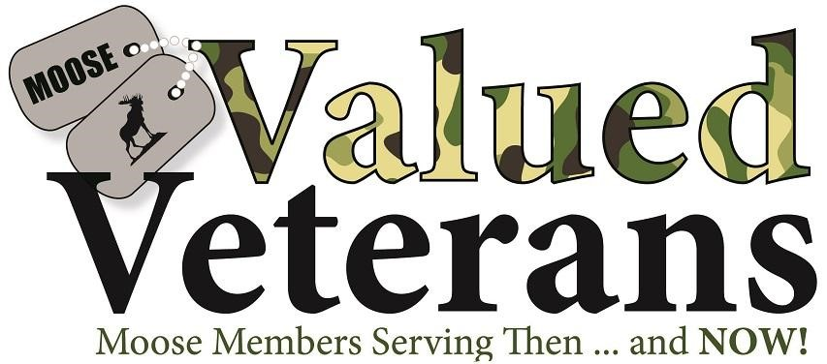

Valued Veterans of the Year selection. The Valued Veterans program also allows for nominations for the “Valued Veteran of the Year,” an award that brings special honor and recognition to one extraordinary Valued Veteran among the members in your Lodge and affiliated Chapter. The person selected should be the ultimate example of a Moose member serving others. Read or download the Valued Veteran of The Year Overview, Nomination Form, and Lodge/Chapter Voting Instructions.

Moose legion did not have an updated website; therefore, I did not download any info. Harry Pagan
These Moose Legionnaires feel an increased level of pride in membership. Opportunities to be leaders and to provide additional support for the Order’s philanthropic causes in relation to Mooseheart & Moosehaven are recognized through involvement in this degree.

>>>>> Obligatory advertising <<<<<

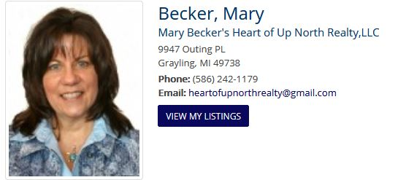
Sponsor of the Lewiston Moose
Summer Car Cruise

Would you like to have your business advertised in the Lewiston Moose Newsletter? We reach more than 600 Moose members every three months. Cost of your ad is ONLY $50.00 per year.
If interested, contact Pat Sieszputowski or Harry Pagán for details.
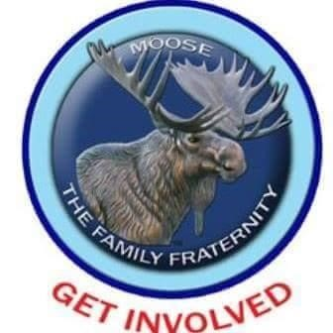

The Lewiston officers and members of our lodge are dedicated and hard working. But, alas, they are a tired and dwindling group of volunteers. As President of the Michigan Moose I have the opportunity to visit lodges around the state and see many different problems. Most of the lodges that are struggling are in their condition due to complacency by their membership. A saying from the past goes something like, we have a very good board of officers and group of volunteers that work around the lodge on a daily and weekly basis. But they have families, jobs, homes to care for; and they get worn out trying to help the lodge every week. They could use a little help. We're not asking for a lot of work. Perhaps a couple hours per week or even per month would make a difference. The old saying goes, "It takes a village to raise a child." In our case it takes a membership to make a successful lodge. We would love to have more activities for our membership to enjoy but, quite frankly, it takes a village. If you can spare a few hours a week or month, contact me and I will contact the right source concerning your interests. I am sure there is something you can do to help out.
Fraternally,
Ron Hoadley
President, M.M.A.
Asst. Territory Mgr. Territory 31
Past Governor, Lodge 2495

September | 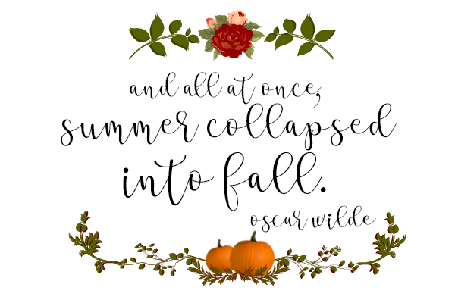
 | 2020
Sunday | Monday | Tuesday | Wednesday | Thursday | Friday | Saturday
 |  | 1 | 2 | 3 | 4 | 5
 |  | Moose Drops |  | Officer’s Mtg. 10 a.m.  LAST CAR SHOW
6 | 7 | 8 | 9 | 10 | 11 | 12
Dist. Mtg, Grayling | 9 Ball | Moose Drops
13 | 14 | 15 | 16 | 17 | 18 | 19
 | 9 Ball | Moose Drops |  |  |  | Gen. Mtg. 10:30 a.m.  Harry’s Pulled pork dinner 4-7 p.m.
20 | 21 | 22 | 23 | 24 | 25 | 26
 | 9 Ball | Moose Drops  Last day of Summer | Hello Fall | Karaoke Begins 7 p.m. |  | Annual Hayride 1 p.m.  $12/person
27 | 28 | 29 | 30
 | 9 Ball | Moose Drops

October | 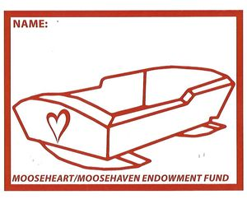
 | 2020
Sunday | Monday | Tuesday | Wednesday | Thursday | Friday | Saturday
 |  | Give a $1.00 to endowment fund.  Ask the Bartender |  | 1 | 2 | 3
 |  |  |  | Officer’s Mtg. 10 a.m.  Karaoke 7 p.m.  (Sandwich Night TBD) |  | Polish Dinner 4-7 p.m.
4 | 5 | 6 | 7 | 8 | 9 | 10
Dist. Mtg. Lewiston | 9 Ball | Moose Drops 5-7 p.m. |  | Karaoke 7 p.m.  (Sandwich Night TBD)
11 | 12 | 13 | 14 | 15 | 16 | 17
 | 9 Ball | Moose Drops 5-7 p.m. |  | Karaoke 7 p.m.  (Sandwich Night TBD) |  | Gen. Mtg. 10:30 a.m.  BBQ Chicken Dinner
18 | 19 | 20 | 21 | 22 | 23 | 24
Shuffleboard Starts  1 p.m. | 9 Ball | Moose Drops 5-7 p.m. |  | Karaoke 7 p.m.  (Sandwich Night TBD)
25 | 26 | 27 | 28 | 29 | 30 | 31
Shuffleboard 1 p.m. | 9 Ball | Moose Drops 5-7 p.m. |  | Karaoke 7 p.m.  (Sandwich Night TBD) |  | Halloween party

November | 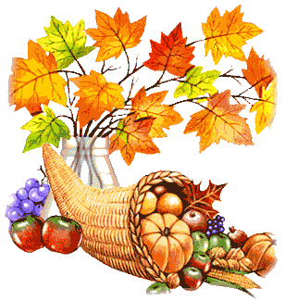  This Photo by Unknown Author is licensed under CC BY-SA-NC
 | 2020
 | LIFE IS GOOD
Sunday | Monday | Tuesday | Wednesday | Thursday | Friday | Saturday
1 | 2 | 3 | 4 | 5 | 6 | 7
Dist. Mtg. Cheboygan  Shuffleboard 1 p.m. | 9 Ball | Moose Drops 5-7 p.m. |  | Officer’s Mtg. 10a.m.  Karaoke 7 p.m.  (Sandwich Night TBD |  | Charity Lasagna Dinner 4-7 p.m. to benefit Patriot House
8 | 9 | 10 | 11 | 12 | 13 | 14
Shuffleboard 1 p.m. | 9 Ball | HAPPY 245th  MARINES!  Moose Drops 5-7 p.m. |  | Karaoke 7 p.m.  (Sandwich Night TBD
No Shuffleboard15 | 16 | 17 | 18 | 19 | 20 | 21
Hunter’s Lunch  10 a.m. – 1 p.m. or till gone | 9 Ball | Moose Drops 5-7 p.m. |  | Karaoke 7 p.m.  (Sandwich Night TBD |  | Gen Mtg. 10:30 a.m.
22 | 23 | 24 | 25 | Free Dinner 26 | 27 | 28
Shuffleboard 1 p.m. | 9 Ball | Moose Drops 5-7 p.m. |  | 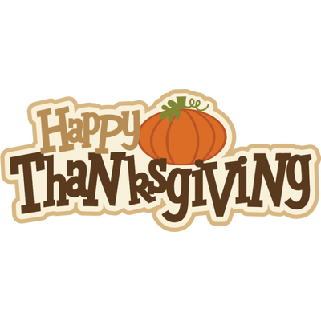  2 p.m. see flyer
29 | 30
Shuffleboard 1 p.m. | 9 Ball

December
2020
Sunday | Monday | Tuesday | Wednesday | Thursday | Friday | Saturday
 |  | 1 | 2 | 3 | 4 | 5
 |  | Moose Drops 5-7 p.m. |  | Officer’s Mtg. 10 a.m.  Karaoke 7 p.m.  (Sandwich Night TBD) |  | Stuffed Pork Chop  Dinner 4-7 p.m.
6 | 7 | 8 | 9 | 10 | 11 | 12
No Dist. Mtg.  Shuffleboard 1 p.m. | 9 Ball | Moose Drops 5-7 p.m. |  | Karaoke 7 p.m.  (Sandwich Night TBD) | Lodge Christmas party  3-7 p.m.
13 | 14 | 15 | 16 | 17 | 18 | 19
Shuffleboard 1 p.m. | 9 Ball | Moose Drops 5-7 p.m. |  | Karaoke 7 p.m.  (Sandwich Night TBD) |  | Gen. Mtg. 10:30
20 | 21 | 22 | 23 | 24 | 25 | 26
Shuffleboard 1 p.m. | 9 Ball | Kitchen Closed
27 | 28 | 29 | 30 | 31
No Shuffleboard | 9 Ball | Kitchen Closed |  | Lodge  Closes at 5:30 p.m. and  Reopens at 7:30 for
 |  |  |  | New Year’s Party
 |  |  |  | Must have ticket to attend

January
2021
Sunday | Monday | Tuesday | Wednesday | Thursday | Friday | Saturday
 |  |  |  |  | 1 | 2
3 | 4 | 5 | 6 | 7 | 8 | 9
No Dist. Mtg. | 9 Ball | Moose Drops 5-7 p.m. |  | Officers Mtg. 10 a.m.  No Karaoke
10 | 11 | 12 | 13 | 14 | 15 | 16
Shuffleboard 1 p.m. | 9 Ball | Moose Drops 5-7 p.m. |  | Karaoke 7 p.m.  (Sandwich Night TBD |  | Gen. Mtg. 10:30 a.m.  Dinner TBA
17 | 18 | 19 | 20 | 21 | 22 | 23
Shuffleboard 1 p.m. | 9 Ball | Moose Drops 5-7 p.m. |  | Karaoke 7 p.m.  (Sandwich Night TBD
24 | 25 | 26 | 27 | 28 | 29 | 30
Shuffleboard 1 p.m. | 9 Ball | Moose Drops 5-7 p.m. |  | Karaoke 7 p.m.  (Sandwich Night TBD
31
Shuffleboard 1 p.m.

